**Naive Bayes Classifier Introductory Overview**

The Naive Bayes Classifier technique is based on the so-called Bayesian theorem and is particularly suited when the dimensionality of the inputs is high. Despite its simplicity, Naive Bayes can often outperform more sophisticated classification methods.

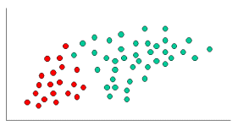

To demonstrate the concept of Naïve Bayes Classification, consider the example displayed in the illustration above. As indicated, the objects can be classified as either GREEN or RED. Our task is to classify new cases as they arrive, i.e., decide to which class label they belong, based on the currently exiting objects.

Since there are twice as many GREEN objects as RED, it is reasonable to believe that a new case (which hasn't been observed yet) is twice as likely to have membership GREEN rather than RED. In the Bayesian analysis, this belief is known as the prior probability. Prior probabilities are based on previous experience, in this case the percentage of GREEN and RED objects, and often used to predict outcomes before they actually happen.

Thus, we can write:

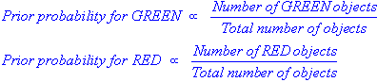

Since there is a total of 60 objects, 40 of which are GREEN and 20 RED, our prior probabilities for class membership are:

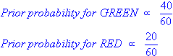

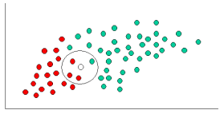

Having formulated our prior probability, we are now ready to classify a new object (WHITE circle). Since the objects are well clustered, it is reasonable to assume that the more GREEN (or RED) objects in the vicinity of X, the more likely that the new cases belong to that particular color. To measure this likelihood, we draw a circle around X which encompasses a number (to be chosen a priori) of points irrespective of their class labels. Then we calculate the number of points in the circle belonging to each class label. From this we calculate the likelihood:

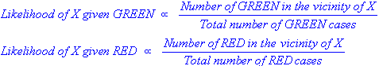

From the illustration above, it is clear that Likelihood of X given GREEN is smaller than Likelihood of X given RED, since the circle encompasses 1 GREEN object and 3 RED ones. Thus:

http://documents.software.dell.com/Statistics/Textbook/snippets/image.ashx?id=6650c135-b0eb-415d-b81d-a7291fdc5fe8

http://documents.software.dell.com/Statistics/Textbook/snippets/image.ashx?id=89a2cd01-b27e-4906-bb95-b0b8f23fa918

Although the prior probabilities indicate that X may belong to GREEN (given that there are twice as many GREEN compared to RED) the likelihood indicates otherwise; that the class membership of X is RED (given that there are more RED objects in the vicinity of X than GREEN). In the Bayesian analysis, the final classification is produced by combining both sources of information, i.e., the prior and the likelihood, to form a posterior probability using the so-called Bayes' rule (named after Rev. Thomas Bayes 1702-1761).

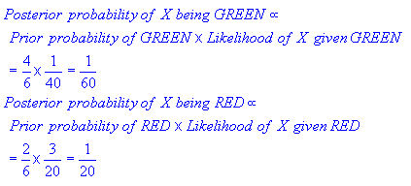

Finally, we classify X as RED since its class membership achieves the largest posterior probability.

**Note.**The above probabilities are not normalized. However, this does not affect the classification outcome since their normalizing constants are the same.